IQ Imbalance Compensation

Under the guidance of Prof. Meenakshi Rawat, Dept. of Electronics and Communication Engg., IIT Roorkee.

By,

Dara Janardhan Hemanth, 13116020

Palakonda Shiva Prasad, 13116047

Tella Tarun Kumar, 13116067

***Introduction:***

Communication receivers that utilize I/Q down conversion are troubled by amplitude and phase mismatches between the analog I and Q branches. These mismatches are unavoidable in practice and reduce the obtainable image frequency attenuation to 20-40 dB range in practical receivers. In wideband multichannel receivers, where the overall bandwidths are in the range of several megahertz and the incoming carriers located at each other’s mirror frequencies have a high dynamic range, the image attenuation of the analog front-end (FE) alone is clearly insufficient. I/Q mismatches decrease the theoretically infinite image rejection ratio (IRR) of the receiver down to 20–40 dB, resulting in crosstalk or interference between mirror frequencies. In particular, when receiving and processing multichannel or multicarrier signals with high dynamic range and/or high-order modulated carriers, the previous mirror-frequency rejection levels are clearly insufficient.



***I/Q Imbalance Models and Mirror frequency interference:***

In general, all the analog components in the receiver I and Q signal paths contribute to the effective I/Q imbalances. One important imbalance source is the I/Q mixer stage. I/Q local oscillator (LO) signals are of the form cos(*ω*LO*t*) and *−g* sin(*ω*LO*t* + *φ*), where *g* and *φ* represent the relative amplitude and phase imbalances, respectively. The equivalent complex LO model is cos(*ω*LO*t*) *− jg* sin(*ω*LO*t* + *φ*) = *K*1 exp[*−jω*LO*t*] + *K*2 exp[*jω*LO*t*], with *K*1 = [1+*g* exp(*−jφ*)]*/*2, and *K*2 = [1 *− g* exp(*jφ*)]*/*2. Then, if the I/Q mixer is the only source of imbalance, the resulting downconverted I/Q signal appears *x*(*t*) = *K*1*\*z(t) + K2*z*(t)* where *z*(*t*) denotes the signal with perfect I/Q balance.

If the spectrum of *z*(*t*) is *Z*(*f*), then the spectrum of *z \**(*t*) is *Z* *(*−f*), and the spectrum of the imbalanced signal *x*(*t*) becomes *X*(*f*) = *G*1 (*f*)*Z*(*f*) + *G*2(*f*) *Z* *(*−f*). Effectively, a scaled and filtered mirror image of the ideal signal is superimposed on top of itself. *A*FE = 10 log10 |K1|2/ |K2|2

***Cirucularity and Properness:***

Auto-correlation function (ACF) is defined as *γs*( *τ* ) = *E*[*s*(*t*) *s∗*(*t − τ* )], where s(t) is a complex random WSS (Wide sense stationary) signal. To fully describe the second-order statistics of a complex random signal *s*(*t*), the ACF may not be sufficient in all cases. So, we use complementary ACF.

*Cs*(*τ* ) = *E* [*s*(*t*) *s* (*t − τ* )] *.*

s(t) is circular if Cs(0) = 0.

s(t) is proper if *C*s(*τ* ) = *E* [*s*(*t*)*s*(*t − τ* )] = 0 *∀ τ.*

Proper signals are always circular, but a circular signal can be improper.

The second order statistics of imbalanced signal x(t) are *γx*(*τ* ) = *E* [*x*(*t*)*x\**(*t − τ* )] = *g*1(*τ* )*∗ g*1*(*−τ* ) *∗ γz*(*τ*) + *g*2(*τ* )*∗ g*2*\**(*−τ* )*∗ γz*(*−τ*).

*Cx*(*τ* ) = *E* [*x*(*t*)*x*(*t − τ* )] = *g*1(*τ* )*∗g*2(*−τ* )*∗ γz*(*τ*) + *g*1(-*τ* ) *∗ g*2(*τ* )*∗ γz*(*−τ)*.

At the signal analysis level, wideband multichannel signals satisfy the circularity or properness assumptions under perfect I/Q balance, given that the individual signals do so. Then, because I/Q mismatches make the observed signal non proper, imbalance compensation is carried out here by restoring the circular or proper nature of the received signal using DSP.

*y*(*t*) = *x*(*t*) + *w*(*t*) *∗ x∗*(*t*)

By substituting *x*(*t*) = *g*1(*t*) *∗ z*(*t*) + *g*2(*t*) *∗ z∗*(*t*)

*g*2(*t*) + *w*2(*t*) *∗ g*1*(*t*) = 0.

**Adaptive Filtering based compensation:**

A practical blind estimation algorithm utilizing instantaneous sample statistics of the received signal is obtained as follows. For notational convenience, we first write the compensator as *y(t) = x(t) + wTt \*****x****\*(t),* where wt = [*w*1*,t , w*2*,t , . . . , wN,t*]T denotes the *N* tap coefficients of the compensator at time index *t*, and **x***∗*(*t*) = [*x∗*(*t*)*, x∗*(*t −*1)*, . . . , x∗*(*t − N* + 1)]T. Then, to null the complementary correlation of the compensator output for the span of the filter wt (*N* samples), the coefficients are updated as wt+1 = wt *− λ***y**(*t*)*y*(*t*) where *λ* denotes the adaptation step size, and **y**(*t*) = [*y*(*t*), *y*(*t −* 1)*, . . . , y*(*t − N* + 1)] T.

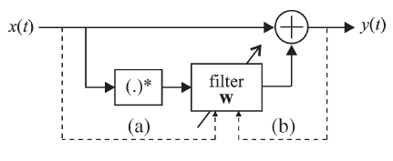

Figure :: Adaptive Filter.

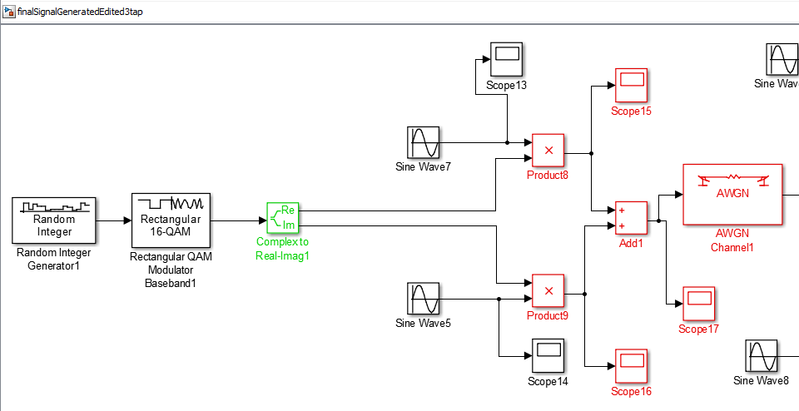

Figure :: Signal Generation and Transmission.

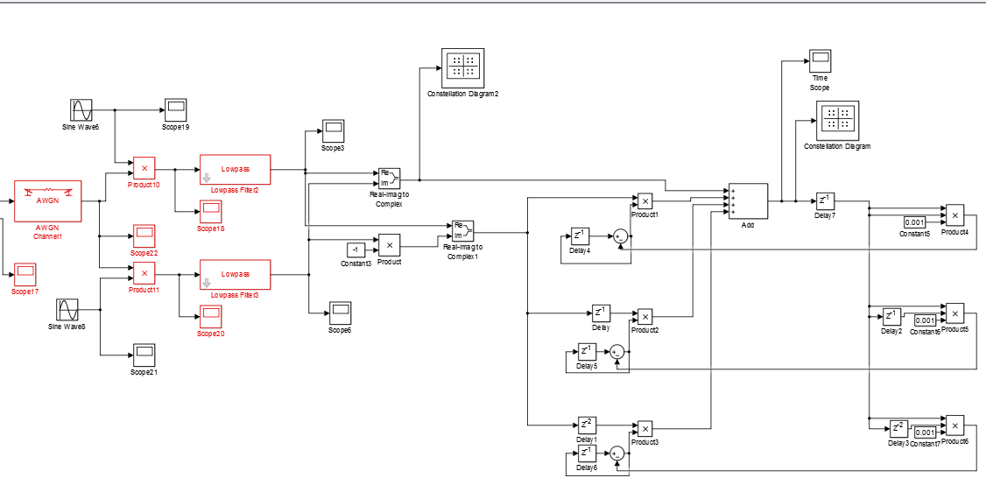

Figure :: Signal Receiving and Removal of IQ imbalance.

Least Square method:

Least square method is a statistical technique to determine the line of best fit for a model. The least squares method is specified by an equation with certain parameters to observed data. This method is extensively used in regression analysis and estimation. We’ll be given a set of input data (with IQ imbalance) and output data (without IQ imbalance). Taking some samples from the data we find the weights and use them for finding the output for new incoming signal.